03/02/2023 meeting with a seminar

During this meeting we discussed what we need to do from the perspective of project manager

We decided to explore how we can make the photo box and present multiple ways to make the box to Julia. In order to make sure we are on the same page and know how to continue.

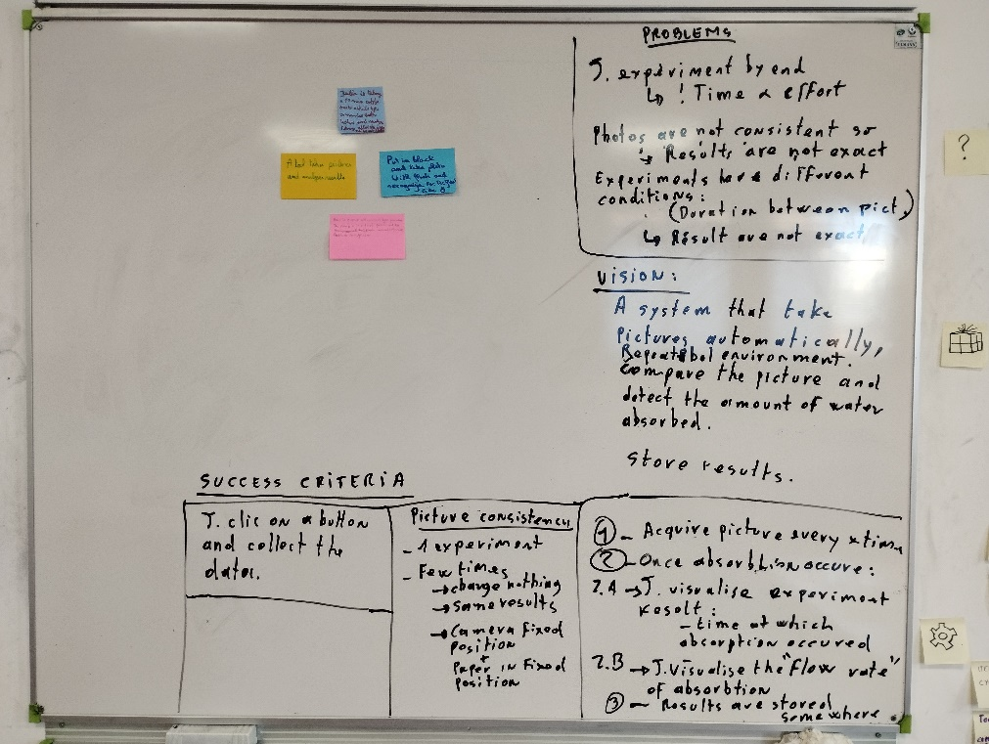

10/02/2023

We showed our presentation to Julia and came to the conclusion that we have to show her a complete budget of everything we need.

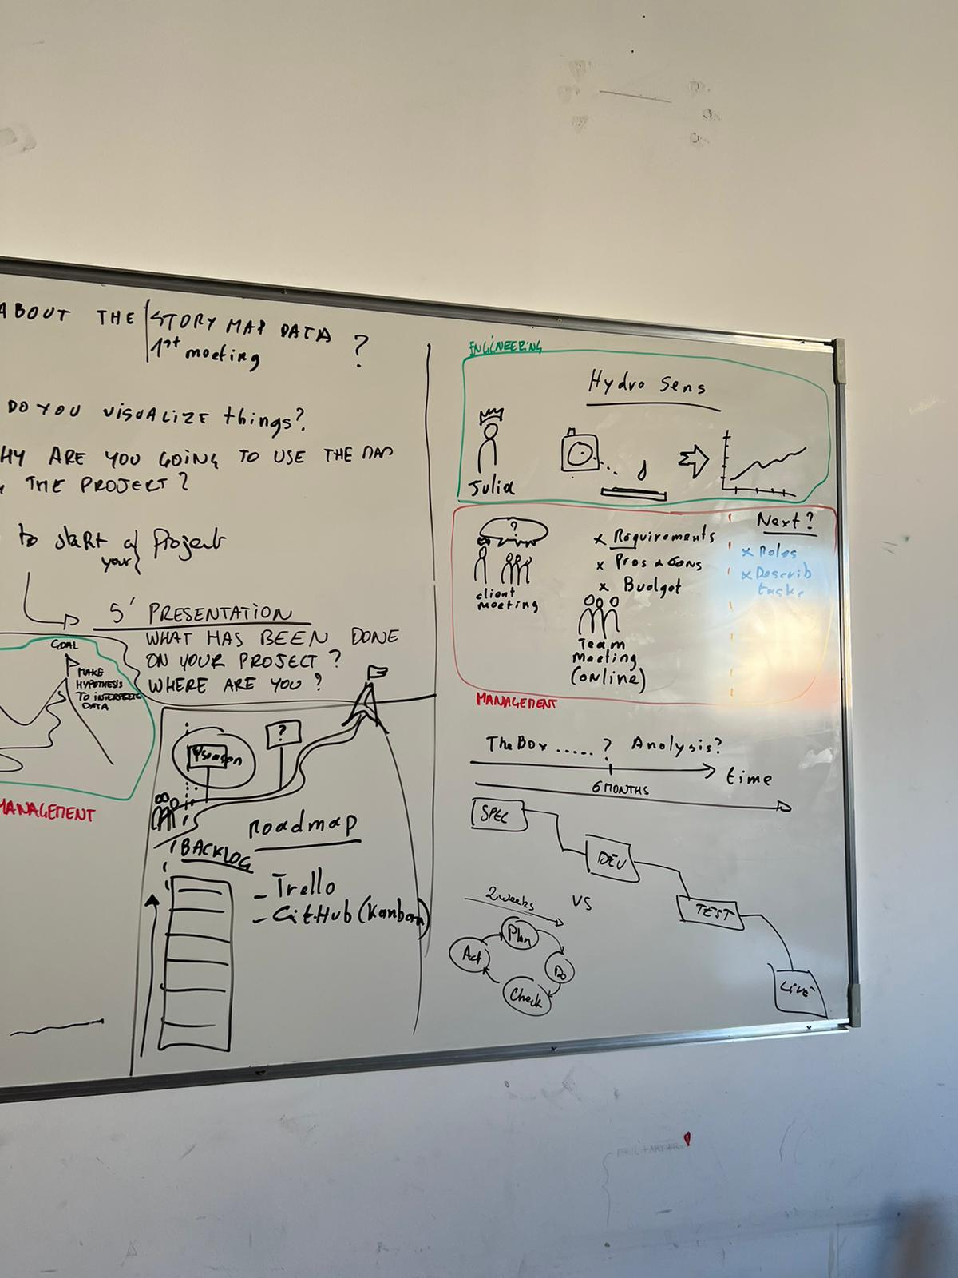what we need:

* Argue why we want to make the box ourselves or not
* Create a budget
* Share our notes with everyone involved